ASSIGNMENT 14.4
K.VIGNANAND RAO
2303A52439
BATCH 41

TASK 01 : Responsive Homepage Layout for a Startup Website
PROMPT: Generate a code for a web page frontend using html and seperate header, content and footer clearly. make sure that layout adjusts accordingly for phone, tablet and desktop
CODE:
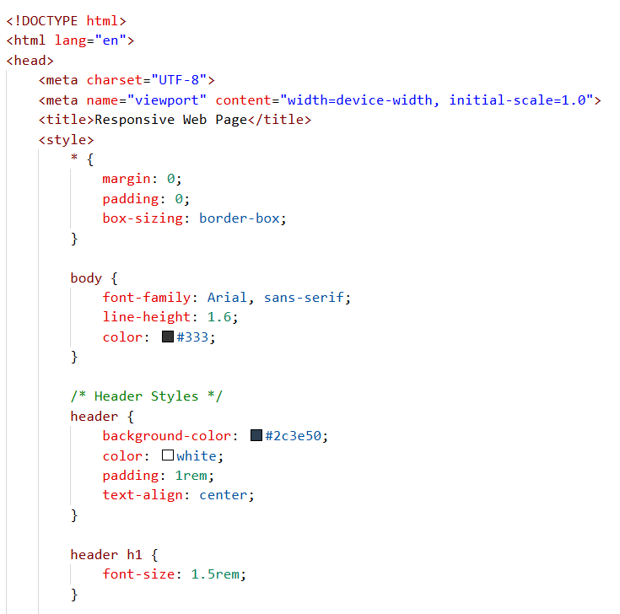
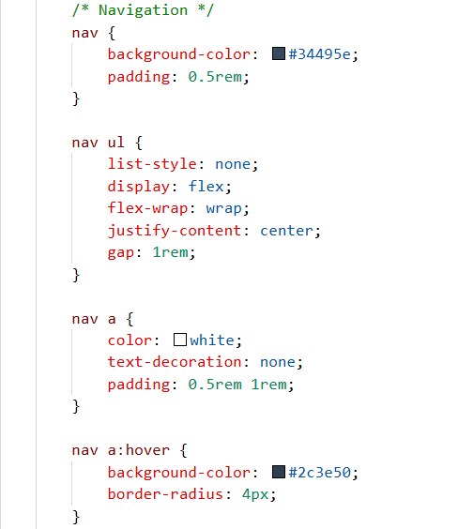
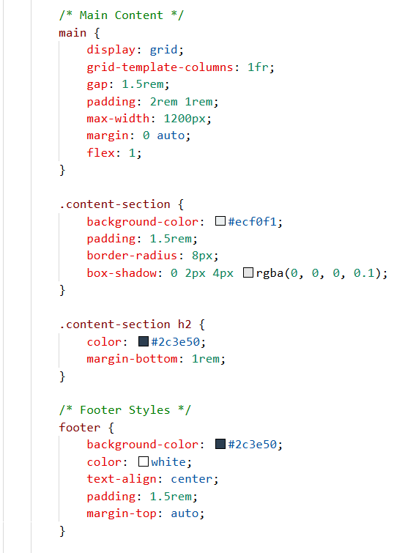
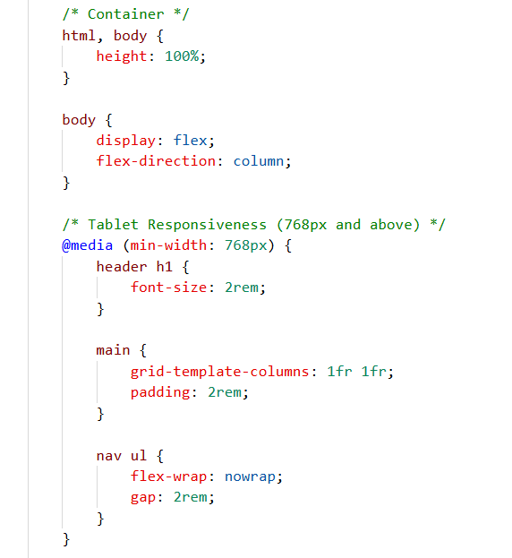
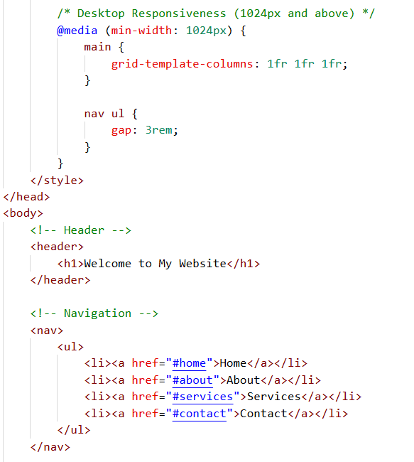
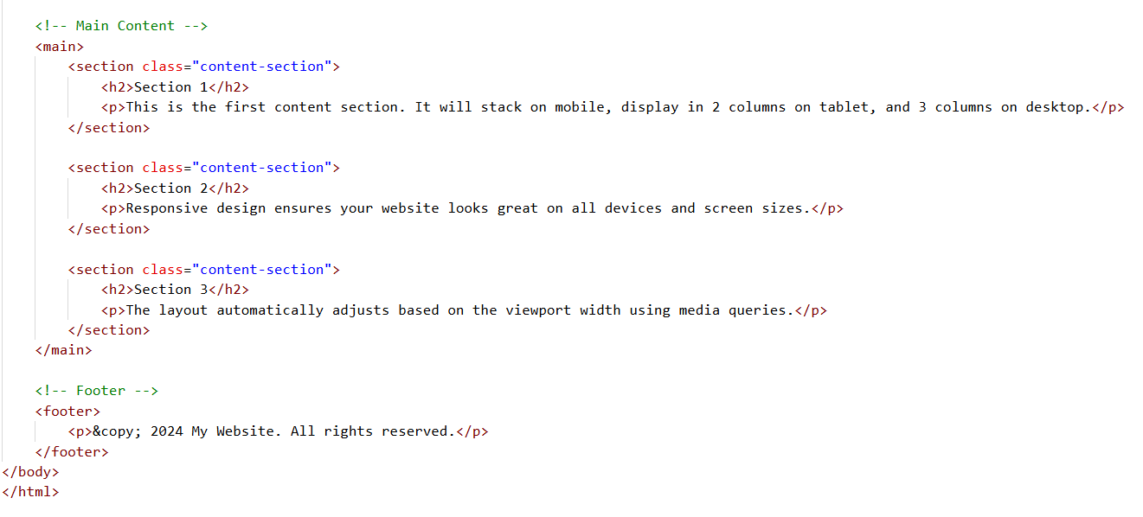
OUTPUT:
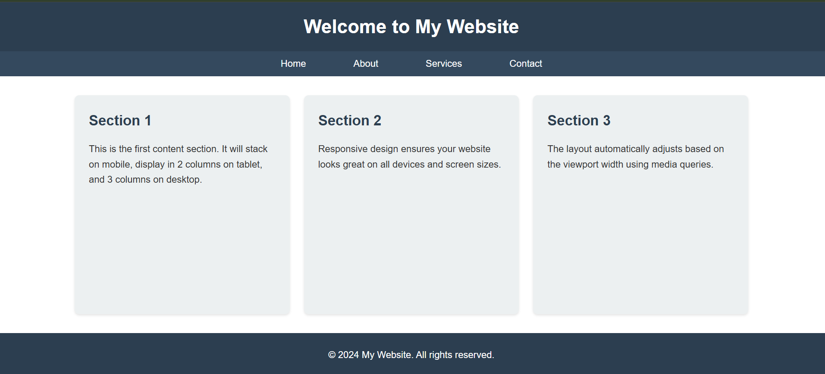
JUSTIFICATION:
By this activity or task, we are able to create a frontend of a website with the help of A.I. assistance which differentiates header, context and footer parts separately and made sure that layout adjusts according to the device which is being used by user like phone, tablet or desktop.

Task 2: Interactive Call-to-Action Button
PROMPT: Add a button to web page using html and generate javascript code such that button must give response of displaying a message or alert message and also say meaning full comments for javascript logic
CODE:
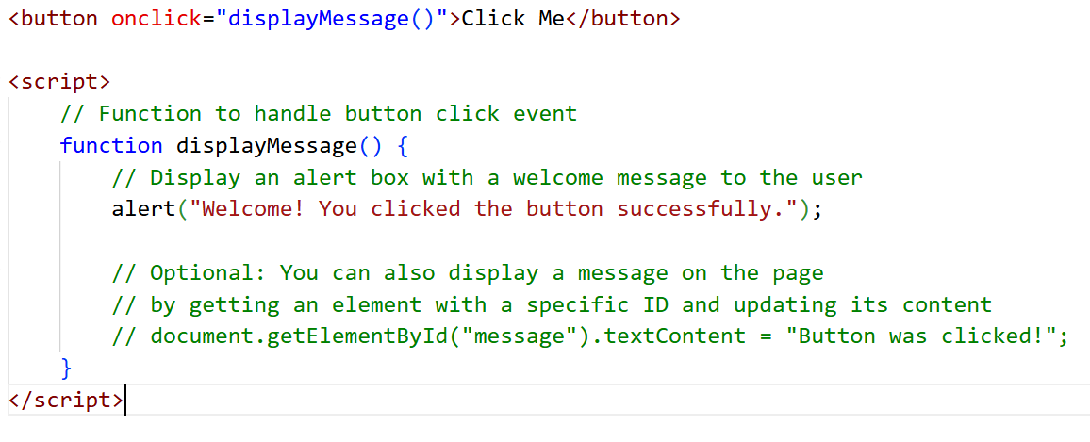
OUTPUT:
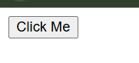
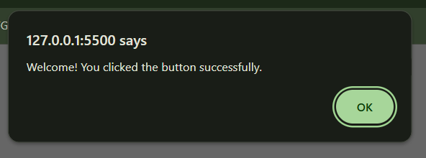
JUSTIFICATION:
In this activity, we have added a button in our web page, that button sends response when clicked on it, this is done by using javascript. Also added required comments for the javascript code logic for easy understanding and helps in improving readability
Task 3: Contact Form with Client-Side Validation
PROMPT: generate a contact form for a company website which has details like name, email, message. Generate a javascript validation logic that prevents empty submissions and check for valid email format and also display clear error message for invalid inputs. Invalid message must be shown as inline error message
CODE:
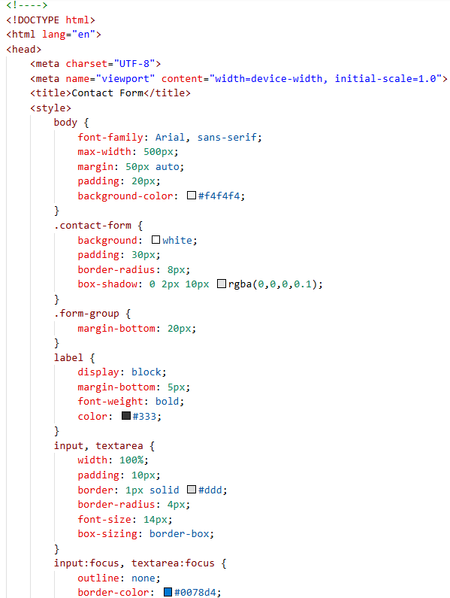
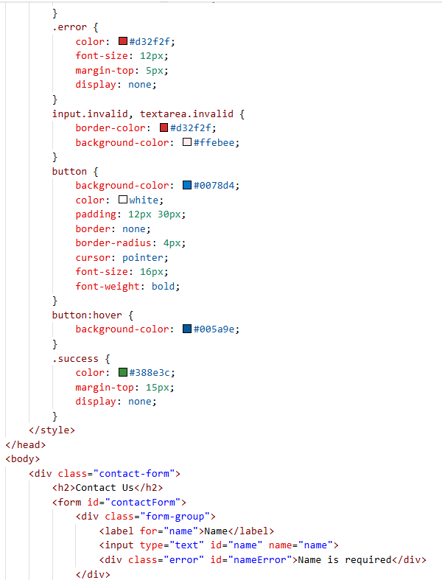
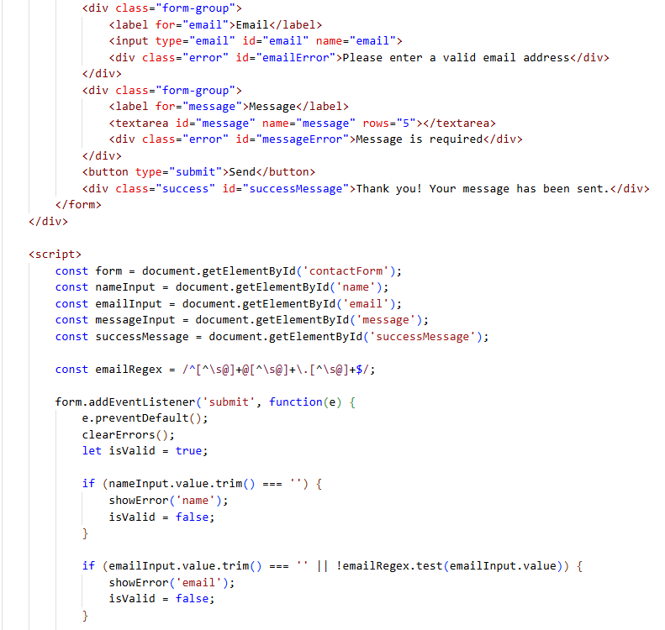
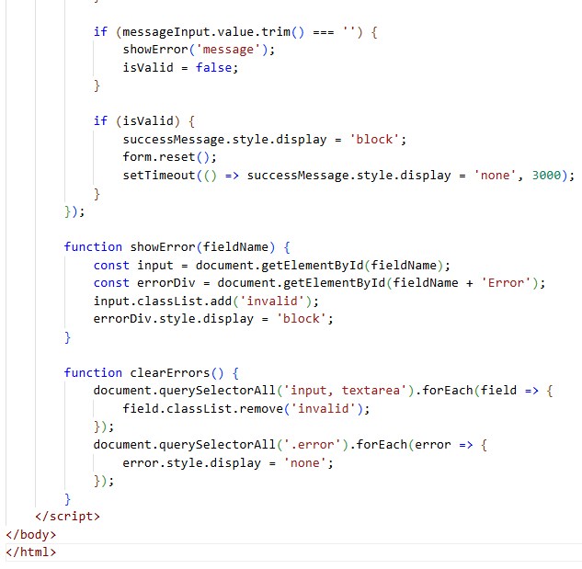
OUTPUT:
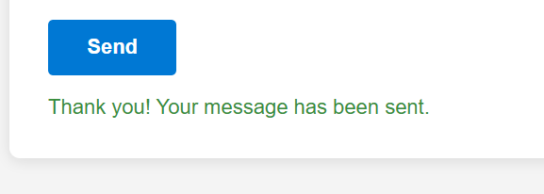
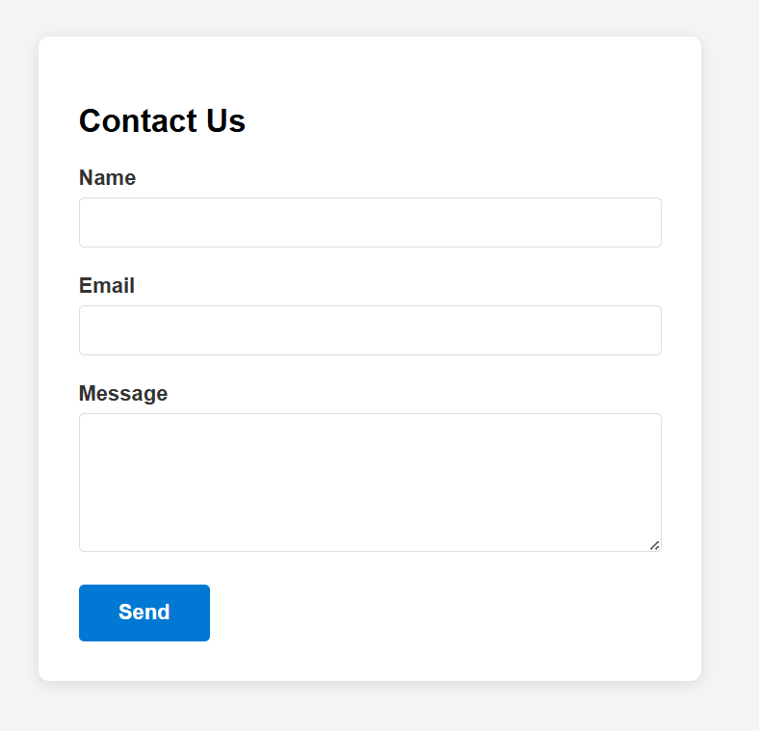
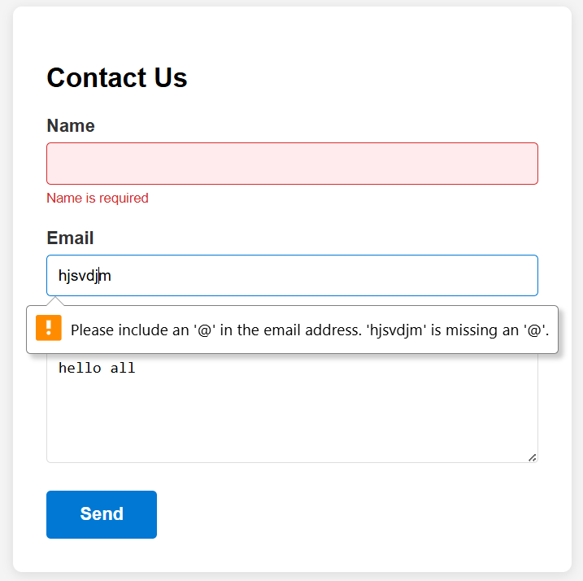
JUSTIFICATION:
In this task, we have used javascript for making a contact us form for a company, made sure that no entry is blank and also checks whether the entered email is verified or not to avoid unusual email entries and also gives error message according to it. Also sends a success message when all the details are entered correctly and accurately.

Task 4: Dynamic List Management for a Product Page
PROMPT: Generate a html code which adds and removes the items dynamically without refreshing the page. Add 2 buttons, Add and Remove, when Add button is clicked, we will get access to add an item and when Remove button is clicked we can remove or delete the item. Make sure changes appear instantly without refreshing the page.
CODE:
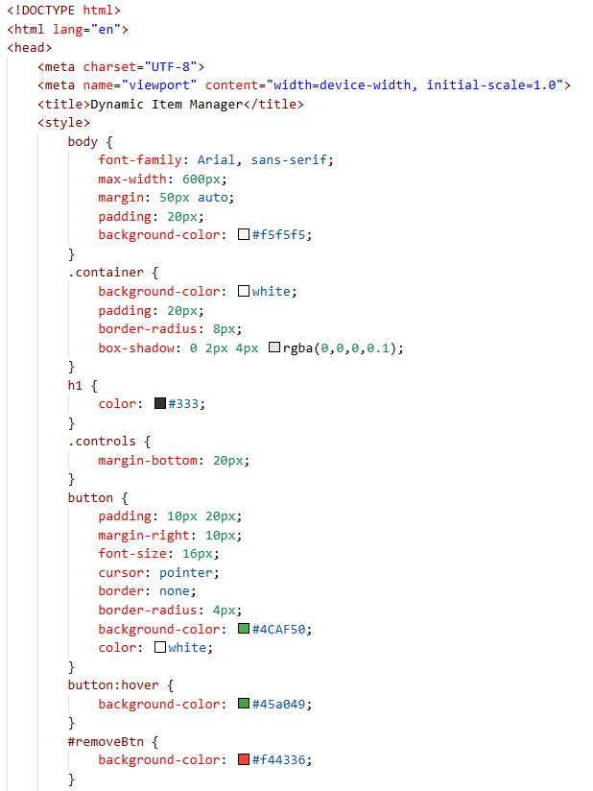
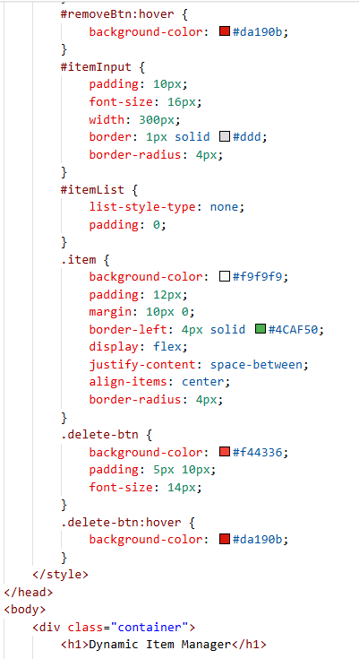
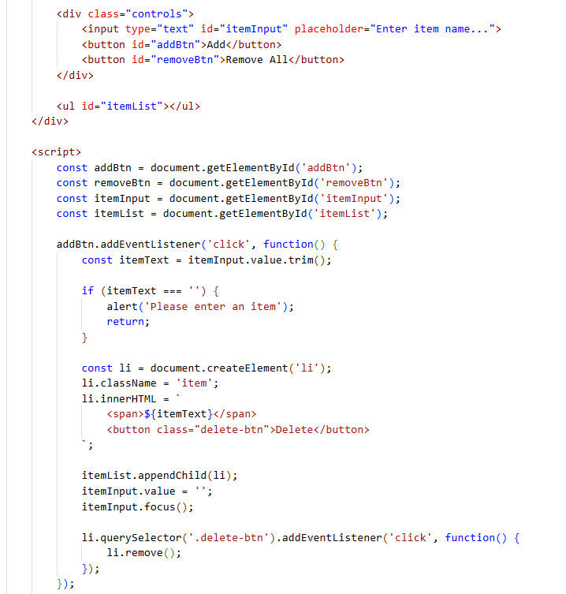
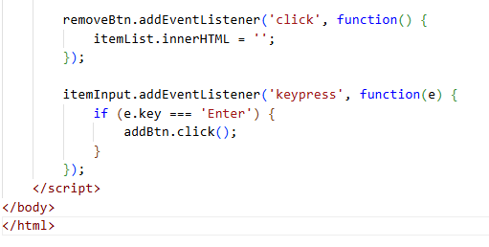
OUTPUT:
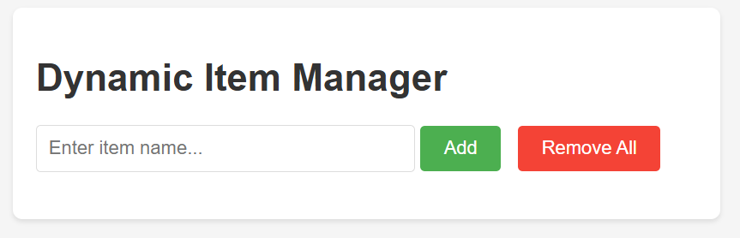
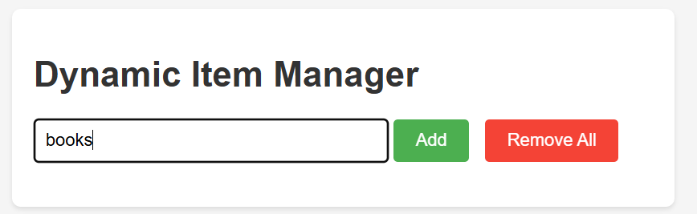
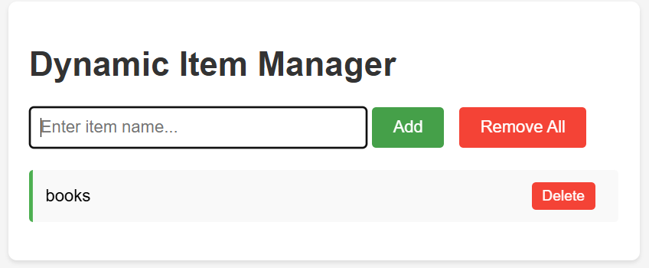
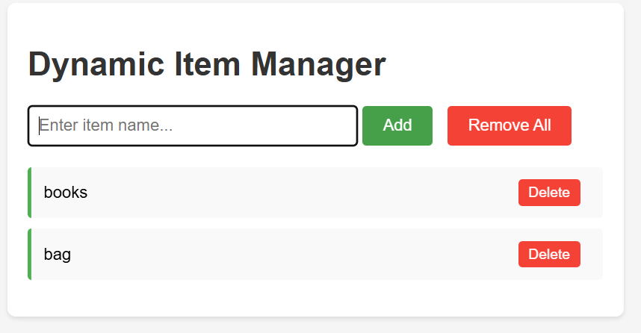
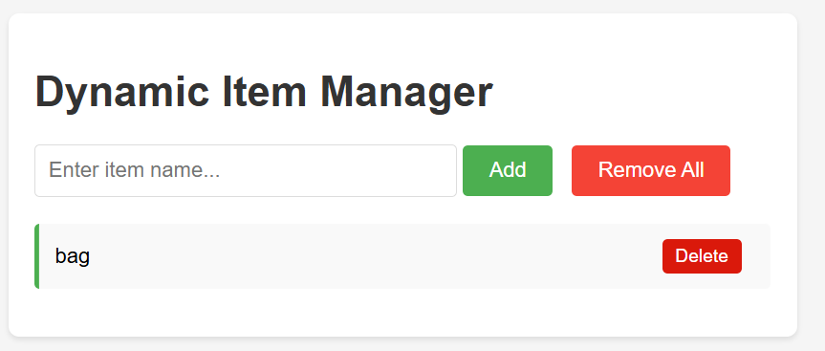
JUSTIFICATION:
In this task, we are creating a web page using html where we are adding and removing the items dynamically, changes are appeared without even refreshing the page which helps in noting down to do things where items must be added and removed without refreshing. Here we introduced buttons like ADD which adds the item, Delete button removes the respective button and Remove All button clears all the items in the list.

Task 5: Modal Popup for User Notifications
PROMPT: generate a html structure modal popup, CSS styling with a semi-transparent background overlay, JavaScript to open and close the model. Include multiple ways to close the model(button or overlay click). Clicking "Open Model" displays the popup, popup overlays the page content clearly.
CODE:
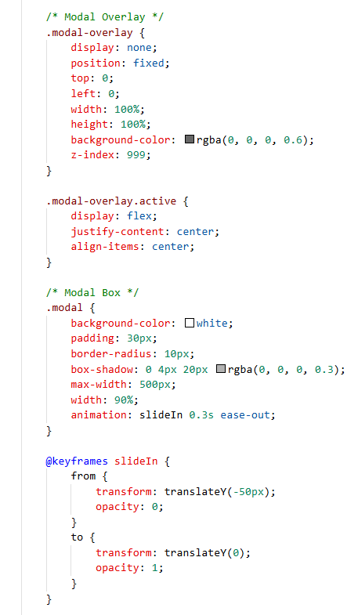
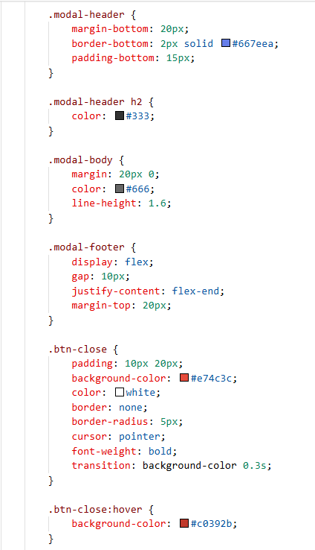
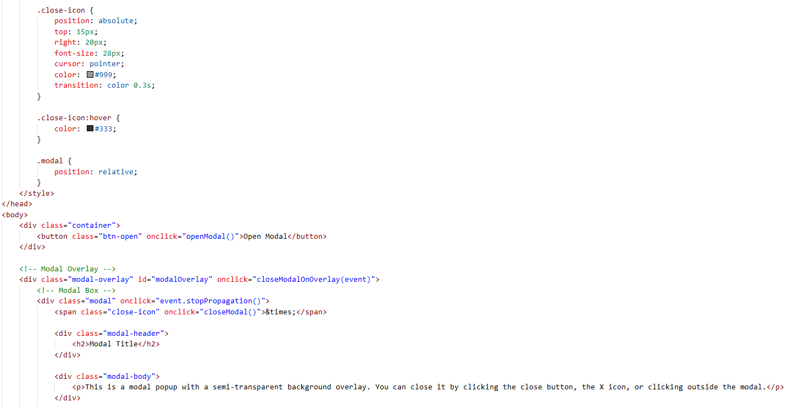
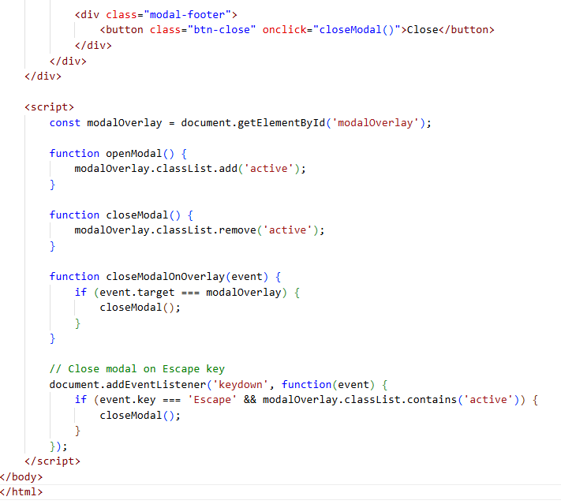
OUTPUT:

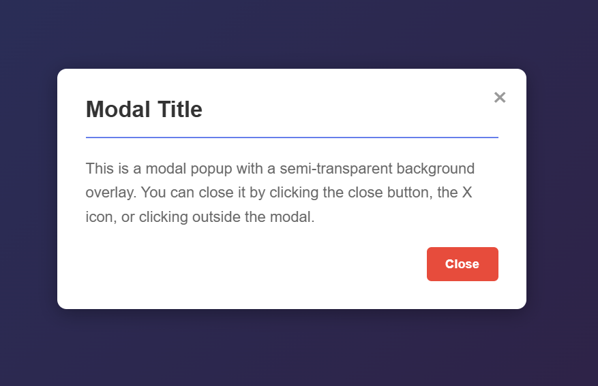
JUSTIFICATION:
In this task, we have added model popup using HTML, CSs styling semi-transparent background overlay, JavaScript to open and close the model, also included multiple ways to close the model. Popup overlays the page content clearly and closes smoothly when instructed.

